Customer Retention & Churn Analytics
Project Overview
A subscription-based company has noticed increasing customer churn and wants to understand:
- Why customers leave
- Which customer segments are at highest risk
- What factors influence retention
- How churn impacts revenue

The objective is to analyse customer behaviour and provide actionable recommendations to improve retention and customer lifetime value.

Business Problem
Acquiring new customers is expensive.
Even a small increase in customer retention can significantly improve profitability.
Management wants answers to:
- Which customers are most likely to churn?
- Which subscription plans experience the highest churn?
- How much revenue is lost due to churn?
- Which customer segments should be targeted for retention campaigns?

Project Goal
Build an end-to-end analytics solution that:
- Identifies churn patterns.
- Segments customers by behaviour and risk.
- Measures retention performance.
- Quantifies business impact.
- Provides strategic recommendations.

Tools
- SQL
- Python (Pandas, NumPy, Matplotlib)
- Power BI
- GitHub

Project Workflow
Phase 1: Data Understanding
Study:
- Customer demographics
- Subscription information
- Billing history
- Service usage
- Churn status
Questions:
- What does each field represent?
- What defines a churned customer?

Phase 2: Data Cleaning
Tasks:
- Handle missing values
- Remove duplicates
- Standardize categorical fields
- Validate numerical values
Output:
- Clean analytical dataset

Phase 3: SQL Analysis
Analyze:
Customer Distribution
- Customers by plan
- Customers by region
- Customers by tenure
Churn Analysis
- Churn rate
- Churn by plan type
- Churn by tenure group
- Churn by payment method
Revenue Analysis
- Monthly recurring revenue
- Revenue lost from churn
- Revenue by customer segment

Phase 4: Customer Segmentation
Create segments:
High Value Customers
High revenue and long tenure
At-Risk Customers
High revenue but likely to churn
New Customers
Recently acquired
Low Engagement Customers
Low activity levels

Phase 5: Cohort Analysis
Track:
- Monthly customer cohorts
- Retention rates
- Lifetime performance
Goal:
Identify which acquisition periods generate the most loyal customers.

Phase 6: Dashboard Development
Dashboard Pages:
Executive Summary
KPIs:
- Total Customers
- Churn Rate
- Revenue
- Revenue Lost
Churn Analysis
- Churn trends
- Churn by plan
- Churn by tenure
Customer Segmentation
- Segment performance
- Risk distribution
Cohort Analysis
- Retention heatmap
- Cohort performance

Architecture
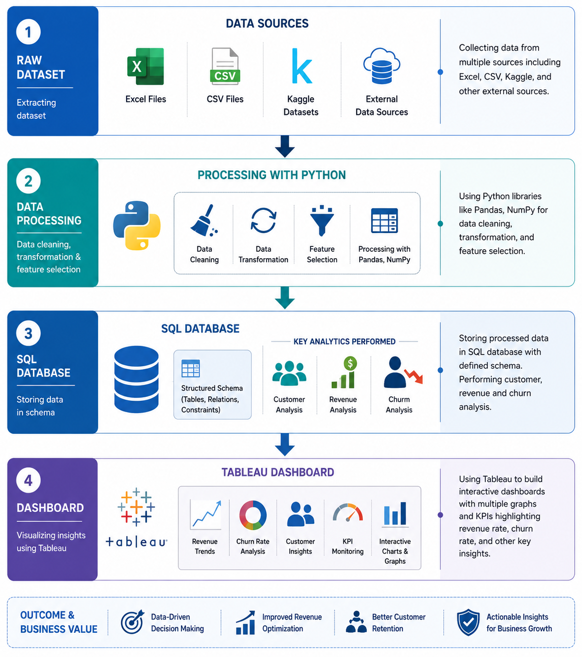

Expected Insights
Examples:
- Month-to-month contracts have significantly higher churn.
- Customers with short tenure are most likely to leave.
- A small customer segment contributes a large share of revenue.
- Retention campaigns should focus on high-value at-risk customers.

